**LIECHTENSTEIN ORTHOPEDIC DEVICES MARKET**

According to Intelli, the Liechtenstein orthopedic devices market was valued at USD 3.13 million in 2024 and is projected to reach USD 4.73 million by 2032, growing at a CAGR of 5.17% from 2024 to 2032.

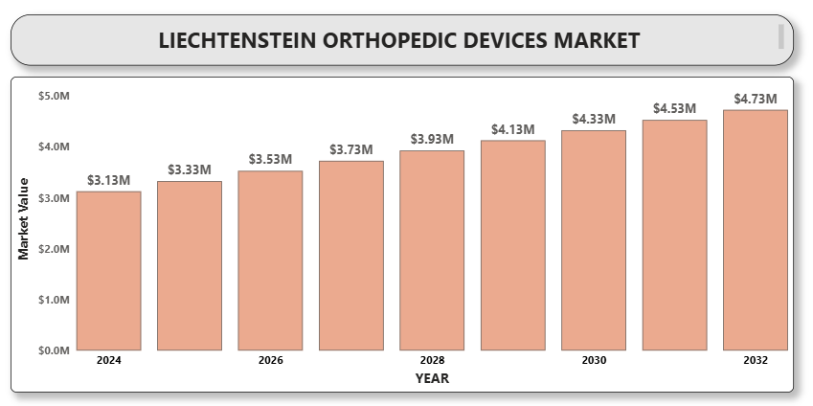

The Liechtenstein orthopedic devices market is witnessing growth due to the increasing prevalence of musculoskeletal disorders, rising aging population, and advancements in orthopedic technologies. Orthopedic devices, including joint reconstruction implants, spinal devices, trauma fixation products, arthroscopic equipment, and orthobiologics, are critical in improving mobility, reducing pain, and enhancing the overall quality of life for patients. Technological innovations such as minimally invasive surgeries, robotic-assisted procedures, and 3D-printed implants are further augmenting market growth.

The modernization of healthcare infrastructure, growing awareness regarding early orthopedic treatment, and government initiatives to enhance healthcare access are supporting the adoption of advanced orthopedic devices in Liechtenstein. Moreover, the increasing trend toward outpatient orthopedic surgeries and the integration of smart technologies in implants are expected to create growth opportunities for the market during the forecast period.

**Liechtenstein Orthopedic Devices Market Definition**

Orthopedic devices refer to medical products designed to correct or replace damaged or degenerated components of the musculoskeletal system, including bones, joints, ligaments, tendons, and muscles. These devices encompass implants, instruments, and supportive devices used in the diagnosis, prevention, treatment, and rehabilitation of orthopedic conditions.

Key categories of orthopedic devices include joint reconstruction implants, spinal implants, trauma fixation products, orthobiologics, and arthroscopy devices. These devices are increasingly being developed using advanced materials and technologies, such as titanium alloys, bioresorbable materials, robotics, and 3D printing, aimed at improving patient outcomes and surgical efficiency.

**Liechtenstein Orthopedic Devices Market Overview**

The Liechtenstein orthopedic devices market is expected to experience steady growth during the forecast period, driven by the rising burden of orthopedic disorders, increasing demand for minimally invasive surgical procedures, and technological advancements in orthopedic implants. The market is also benefiting from a shift toward personalized medicine, resulting in the growing use of patient-specific implants manufactured using 3D printing technologies.

Challenges such as high treatment costs, regulatory hurdles, and limited healthcare expenditure may slightly restrain the market growth. However, increasing collaborations between healthcare providers and medical device manufacturers, expanding reimbursement coverage, and the growing trend toward outpatient orthopedic procedures are likely to offer new opportunities.

**Liechtenstein Orthopedic Devices Market Segment Analysis**

**By Product Type**

* Joint Reconstruction Devices
* Spinal Devices
* Trauma Fixation Devices
* Arthroscopic Devices
* Orthobiologics

**By End User**

* Hospitals
* Orthopedic Clinics
* Ambulatory Surgical Centers
* Homecare Settings

**By Technology**

* Conventional Devices
* A close-up of hands holding a tablet and a pen

  Description automatically generatedMinimally Invasive Surgery Devices
* Robotic-Assisted Devices
* 3D-Printed Orthopedic Implants

**By Application**

* Joint Reconstruction
* Spinal Disorders
* Sports Injuries
* Trauma Cases
* Other Applications

**Liechtenstein Orthopedic Devices Market Competitive Landscape**

The Liechtenstein orthopedic devices market is moderately competitive, characterized by the presence of established multinational corporations and emerging players focusing on innovative orthopedic solutions. Key strategies adopted by market participants include product development, mergers and acquisitions, strategic partnerships, and geographic expansions.

**Liechtenstein Orthopedic Devices Market Key Player Profiles**

**10.1 Stryker Corporation**

**10.2 Zimmer Biomet Holdings, Inc.**

**10.3 Medtronic PLC**

**10.4 Johnson & Johnson (DePuy Synthes)**

**10.5 Smith & Nephew PLC**

**10.6 B. Braun Melsungen AG**

**10.7 DJO Global, Inc. (Enovis)**

**10.8 NuVasive, Inc.**

**10.9 Exactech, Inc.**

**10.10 Globus Medical, Inc.**

**Liechtenstein Orthopedic Devices Market Key Developments**

* **At the AAOS 2025** Annual Meeting in San Diego, Stryker unveiled the next generation of its Mako SmartRobotics™ platform, highlighting cutting-edge advancements across hip, knee, spine, and shoulder procedures. The showcase demonstrated enhanced precision, improved surgical planning, and greater efficiency in orthopedic interventions, reinforcing Stryker's commitment to innovation in robotic-assisted surgery.
* **In 2024**, Smith & Nephew secured the second-leading position in the global robotic-assisted orthopedic surgery system market. The company’s portfolio includes two robotic systems: NAVIO™ and its advanced successor, CORI™. CORI™ represents a next-generation solution with enhanced capabilities built upon the foundation of NAVIO™. With the launch and growing adoption of CORI™, Smith & Nephew is in the process of phasing out the NAVIO™ system, signaling a strategic shift toward more advanced and efficient robotic surgical technologies.

**Market Attractiveness**

The Liechtenstein orthopedic devices market presents attractive growth opportunities owing to the rising aging population, increasing preference for minimally invasive orthopedic surgeries, technological advancements, and the growing demand for personalized orthopedic care.

**Porter’s Five Forces Analysis**

|  |  |
| --- | --- |
| **Forces** | **Impact** |
| Threat of New Entrants | Moderate |
| Bargaining Power of Suppliers | Moderate |
| Bargaining Power of Buyers | High |
| Threat of Substitutes | Low |
| Industry Rivalry | High |

**TABLE OF CONTENTS**

1. **INTRODUCTION OF LIECHTENSTEIN ORTHOPEDIC DEVICES MARKET**1.1 Overview of the Market  
   1.2 Scope of Report  
   1.3 Assumptions
2. **EXECUTIVE SUMMARY**
3. **RESEARCH METHODOLOGY**3.1 Data Mining  
   3.2 Validation  
   3.3 Primary Interviews  
   3.4 List of Data Sources
4. **LIECHTENSTEIN ORTHOPEDIC DEVICES MARKET OUTLOOK**4.1 Overview  
   4.2 Market Dynamics  
   4.2.1 Drivers  
   4.2.2 Restraints  
   4.2.3 Opportunities  
   4.2.4 Trends  
   4.3 Porter’s Five Forces Model  
   4.4 Value Chain Analysis
5. **LIECHTENSTEIN ORTHOPEDIC DEVICES MARKET, BY PRODUCT TYPE**5.1 Joint Reconstruction Devices  
   5.2 Spinal Devices  
   5.3 Trauma Fixation Devices  
   5.4 Arthroscopic Devices  
   5.5 Orthobiologics
6. **LIECHTENSTEIN ORTHOPEDIC DEVICES MARKET, BY END USER**6.1 Hospitals  
   6.2 Orthopedic Clinics  
   6.3 Ambulatory Surgical Centers  
   6.4 Homecare Settings
7. **A close-up of hands holding a tablet and a pen

   Description automatically generatedLIECHTENSTEIN ORTHOPEDIC DEVICES MARKET, BY TECHNOLOGY**7.1 Conventional Devices  
   7.2 Minimally Invasive Surgery (MIS) Devices  
   7.3 Robotic-Assisted Devices  
   7.4 3D-Printed Orthopedic Implants
8. **LIECHTENSTEIN ORTHOPEDIC DEVICES MARKET, BY APPLICATION**8.1 Joint Reconstruction  
   8.2 Spinal Disorders  
   8.3 Sports Injuries  
   8.4 Trauma Cases  
   8.5 Other Applications
9. **LIECHTENSTEIN ORTHOPEDIC DEVICES MARKET COMPETITIVE LANDSCAPE**9.1 Overview  
   9.2 Company Market Ranking  
   9.3 Key Development Strategies
10. **COMPANY PROFILES  
    10.1 Stryker Corporation**10.1.1 Overview  
    10.1.2 Financial Performance  
    10.1.3 Product Outlook  
    10.1.4 Key Developments  
    **10.2 Zimmer Biomet Holdings, Inc.**10.2.1 Overview  
    10.2.2 Financial Performance  
    10.2.3 Product Outlook  
    10.2.4 Key Developments  
    **10.3 Medtronic PLC**10.3.1 Overview  
    A close-up of hands holding a tablet and a pen

    Description automatically generated10.3.2 Financial Performance  
    10.3.3 Product Outlook  
    10.3.4 Key Developments  
    **10.4 Johnson & Johnson (DePuy Synthes)**10.4.1 Overview  
    10.4.2 Financial Performance  
    10.4.3 Product Outlook  
    10.4.4 Key Developments  
    **10.5 Smith & Nephew PLC**10.5.1 Overview  
    10.5.2 Financial Performance  
    10.5.3 Product Outlook  
    10.5.4 Key Developments  
    **10.6 B. Braun Melsungen AG**10.6.1 Overview  
    10.6.2 Financial Performance  
    10.6.3 Product Outlook  
    10.6.4 Key Developments  
    **10.7 DJO Global, Inc. (Enovis)**10.7.1 Overview  
    10.7.2 Financial Performance  
    10.7.3 Product Outlook  
    10.7.4 Key Developments  
    **10.8 NuVasive, Inc.**10.8.1 Overview  
    10.8.2 Financial Performance  
    10.8.3 Product Outlook  
    10.8.4 Key Developments  
    **10.9 Exactech, Inc.**10.9.1 Overview  
    10.9.2 Financial Performance  
    10.9.3 Product Outlook  
    10.9.4 Key Developments  
    **10.10 Globus Medical, Inc.**10.10.1 Overview  
    10.10.2 Financial Performance  
    10.10.3 Product Outlook  
    10.10.4 Key Developments
11. **KEY DEVELOPMENTS**11.1 Product Launches/Developments  
    11.2 Mergers and Acquisitions  
    11.3 Business ExpansionsA close-up of hands holding a tablet and a pen

    Description automatically generated
12. **APPENDIX**15.1 Related Research